Mid-Semester Project: Monitor and Log Environmental Conditions
Course: Envirotech – DIY Sensors for Environmental Research
Arie Kobylansky (Gurdzhi) 207223447
2026

Introduction

Indoor environmental quality (IEQ) refers to the conditions inside a building which affect occupants’ comfort and wellbeing. It includes thermal comfort, air quality, lighting, and acoustics. These parameters have a significant influence on health, productivity, and quality of life. Among the leading causes of dissatisfaction in indoor spaces are poor thermal conditions, while insufficient air quality has been linked to a phenomenon known as the Sick Building Syndrome (SBS), which is a set of health symptoms directly tied to time spent in a building that can impair performance and productivity. Despite growing awareness on IEQ’s importance, there is no standardized and integrated commercial toolkit for its measurement, prompting researchers to develop custom sensor-based systems, which are tailored to specific study needs (Dorizas, P.V. et al., 2018).

Hence, this project aims to be part of the solution for low-cost, open-source IEQ monitoring and measurement. It is a system designed to detect and monitor the three key IEQ indicators, namely, log temperature (T), relative humidity (H), and carbon dioxide concentration (CO₂), inside a residential living room over a minimum of three consecutive days. It was built using an Arduino Uno microcontroller, an Adafruit SHT40 T/RH sensor, a Seeed Studio CD30 CO₂/T/RH sensor, and a SparkFun MicroSD breakout for local data storage. Measurements were recorded at 30-second intervals using Arduino’s internal millisecond timer as the time reference. The system was powered continuously via a standard 5V AC/DC adapter, and no sensor calibration or custom enclosure was employed, as is in line with the scope of a first-iteration DIY monitoring system.

Summary of the Project’s Hardware Components and Materials

 | Component | Model | Role in System | Link
1 | Microcontroller | Arduino Uno R3 | Main controller | DFRobot
2 | T/RH Sensor | Adafruit SHT40 | Temperature & humidity | Adafruit
3 | CO₂/T/RH Sensor | Seeed SCD30 Grove | Co₂, temperature,  & humidity | Seeed Studio
4 | MircoSD Breakout | SparkFun Level Shifting MicroSD Breakout | SD data logging | SparkFun
5 | I2C Hub | DFRobot Gravity I2C Hub V1.0 | Splits I2C bus between SHT40 and SCD30 | DFRobot
6 | SD Card | MicroSD (FAT32) | Data storage
7 | Power Supply | 5V USB AC/DC adapter | System power
8 | Cables | Jumper wires, USB-B cable | Connections

System Photos

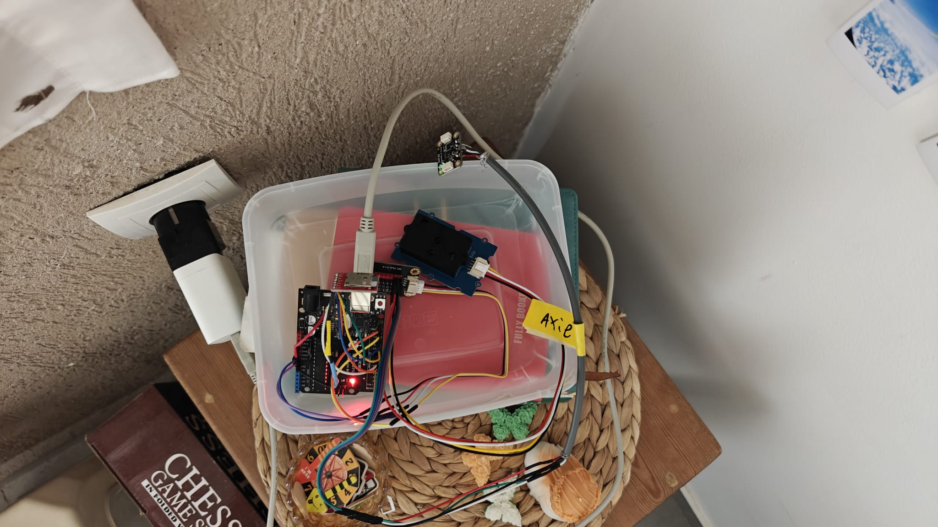

Image of the Project
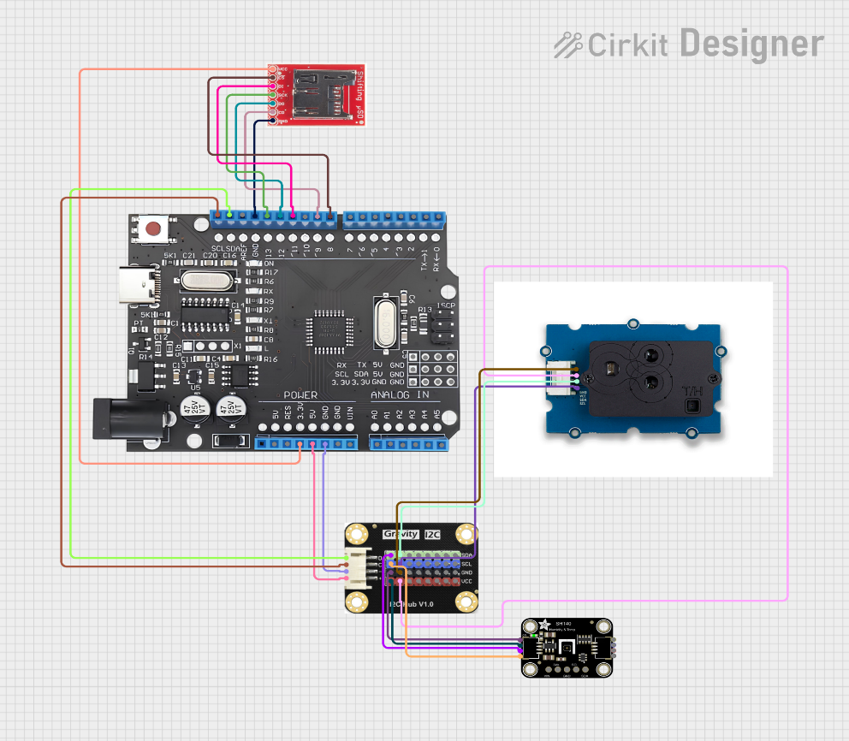

Connection Diagram

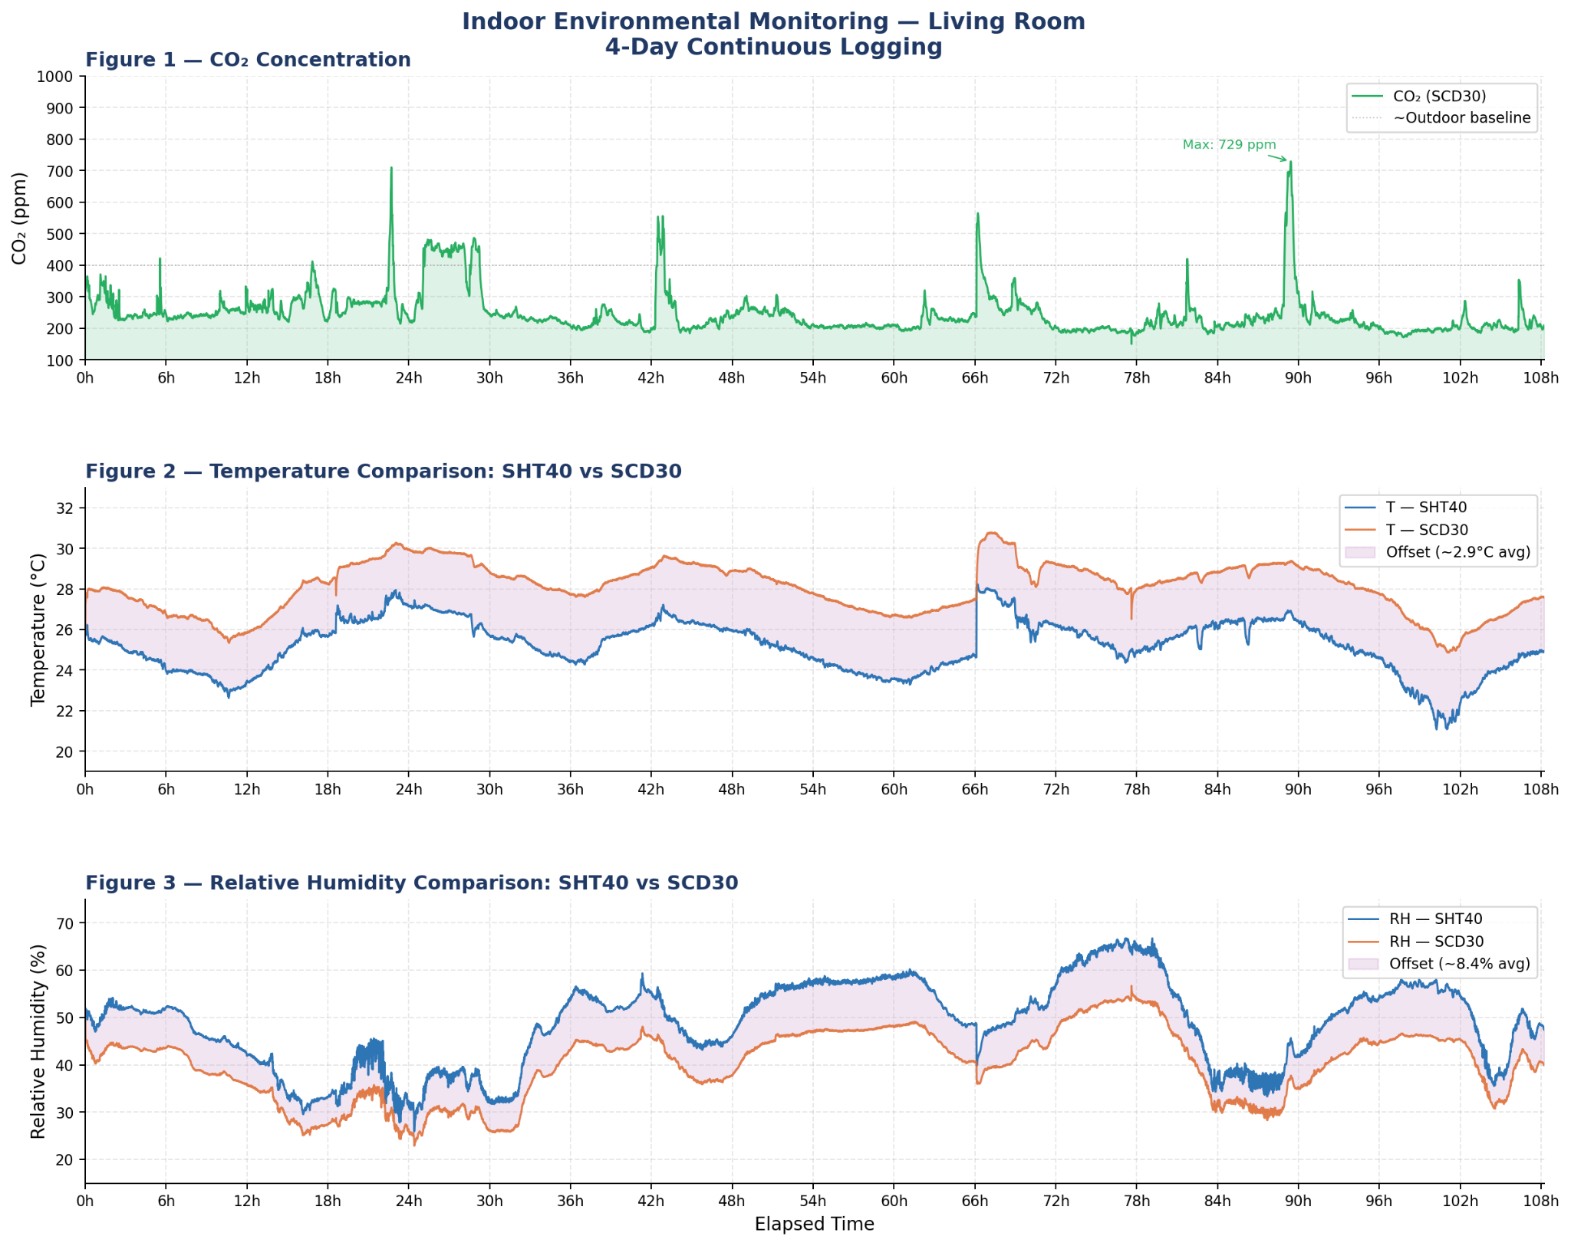
Results
4-Day Continuous Logging of Indoor Environmental Monitoring
in a Residential Living Room.

Conclusion
The DIY monitoring system was successfully tested for a duration of roughly 4.5 days, capturing CO₂ levels alongside T/RH data every 30 seconds to produce a dataset exceeding 12,900 observations. Throughout this measurement period, the setup exhibited robust and dependable behavior, as was characterized by a high degree of correlation in temporal trends between sensors for each of the three environmental indicators assessed. Living room thermal conditions fluctuated between 21.1°C and 28.2°C (mean 25.2°C, SHT40), following diurnal patterns that were influenced by external climate and internal occupancy. A systematic positive deviation of nearly nearly +2.9°C was noted in the SCD30 sensor compared to the SHT40 across the monitoring period. Correspondingly, relative humidity (RH) varied from 25.9% to 66.8% (SHT40 average 48.5%), with the SCD30 reporting values approximately 8.4% lower. Regardless of these fixed offsets, both devices demonstrated highly correlated temporal trends, validating the system’s ability to accurately monitor environmental shifts.

Carbon dioxide levels spanned 150 to 729 ppm, maintaining a campaign average of 248 ppm. The recorded data clearly reflected occupancy patterns, with CO₂ concentrations ascending during periods of human presence and receding during ventilation or vacancy. Two specific anomalies were detected: at roughly hour 66, a localized power failure triggered a controller reset, resulting in a temporal discontinuity; at approximately hour 90, a significant CO₂ peak was logged. This latter event was associated with a combustion occurrence (a burning popcorn incident), which briefly elevated concentrations far beyond the baseline.

The first-iteration DIY monitoring platform demonstrated its efficacy as a cost-effective tool for integrated IEQ logging. Primary constraints observed during this trial included the lack of a real-time clock (RTC) for precise event timestamping and the system's vulnerability to electrical interruptions. Subsequent developments could mitigate these issues by integrating an RTC module and an auxiliary battery source.

Reference:

Dorizas, P.V. et al. (2018). A holistic approach for the assessment of the indoor environmental quality... Journal of Building Engineering. https://doi.org/10.1016/j.jobe.2018.07.007

